**Kaggle Learn**

**1. Intro to Programming**

**1.1 Arithmetic and Variables**



**PEMDAS (order of operations):**







**Variables names rules:**



**1.2 Functions**



**1.3 Data Types**

When you multiple an integer or float by a boolean with value True, it just returns that same integer or float (and is equivalent to multiplying by 1). If you multiply an integer or float by a boolean with value False, it always returns 0. This is true for both positive and negative numbers. If you multiply a string by a boolean with value True, it just returns that same string. And if you multiply a string by a boolean with value False, it returns an empty string (or a string with length zero).

When you add booleans, adding False is equivalent to adding 0, and adding True is equivalent to adding 1.



**1.4 Conditions and Conditional Statements**





**1.5 Intro to Lists**

You can also pull a segment of a list (for instance, the first three entries or the last two entries). This is called slicing. For instance:

* to pull the first x entries, you use [:x], and
* to pull the last y entries, you use [-y:].

**2. Python**

**2.1 Hello, Python**



a % b example (the modulo operator):



**2.2 Functions and Getting Help**

Use the help() function to get information on some function:



Docstrings or comments in your own functions:



The print() function has a special feature sep that specifies a separator between values. If you don’t specify a separator your values will be separated by spaces.



Calling functions on functions:



**2.3 Booleans and Conditionals**



Function that checks if a number is odd:



**2.4 Lists**

Swapping two variables:



**2.6 Strings and Dictionaries**

Important uses of the backslash character:



**3. Intro to SQL**

**3.1 Getting Started With SQL and BigQuery**



Use this code to fetch a dataset from BigQuery:



**3.3 GROUP BY, HAVING & COUNT**

When using GROUP BY with COUNT you can use COUNT(1) to count the rows in each group.

**4. Advanced SQL**

**4.1 JOINs and UNIONs**





Use UNION ALL to place the second table below the first, use UNION DISTINCT if you want to remove duplicate values.

**4.2 Analytic Functions**

Example of a moving average:









**Google Cloud documentation on** [**Window functions**](https://cloud.google.com/bigquery/docs/reference/standard-sql/window-function-calls)**.**

Calculating the cumulative (cumsum) number of trips per day:



Track beginning and ending station on October 25, 2025 for each bike:





**4.3 Nested and Repeated Data**

**Nested data (datatype STRUCT or RECORD):**





**Repeated data (datatype REPEATED):**





**Nested and repeated data:**





Unnesting example:



**4.4 Writing Efficient Queries**

1. Only select the columns you want;
2. Read less data;
3. Avoid N:N JOINs (many to many connections).

**5. Pandas**

**5.3 Summary Functions and maps**

To subtract a mean value from a column you can use the .map() function:



Or .apply():



Or the pandas functional:



You can also combine columns this way:



**5.5 Data Types and Missing Values**

Return the datatype of every column in a DataFrame using df.dtypes:



**6. Data Cleaning**

**6.1 Handling Missing Values**

Calculate the number of missing values in the first 10 columns of a DataFrame using df.isnull().sum():



To calculate the percentage of missing data you can use np.product(df.shape):





Remove all rows/columns that contain missing values using df.dropna():





Use df.fillna() to specify the value you want to fill the null/NA values with:





**6.2 Scaling and Normalization**

**Scaling**

Changing the range of your data. This means that you're transforming your data so that it fits within a specific scale, like 0-100 or 0-1. You want to scale data when you're using methods based on measures of how far apart data points are, like support vector machines (SVM) or k-nearest neighbors (KNN). With these algorithms, a change of "1" in any numeric feature is given the same importance.

For example, you might be looking at the prices of some products in both Yen and US Dollars. One US Dollar is worth about 100 Yen, but if you don't scale your prices, methods like SVM or KNN will consider a difference in price of 1 Yen as important as a difference of 1 US Dollar! This clearly doesn't fit with our intuitions of the world. With currency, you can convert between currencies. But what about if you're looking at something like height and weight? It's not entirely clear how many pounds should equal one inch (or how many kilograms should equal one meter).

Scaling example:



**Normalization**

Changing the shape of the distribution of your data. The point of normalization is to change your observations so that they can be described as a normal distribution (the “bell curve”).

In general, you'll normalize your data if you're going to be using a machine learning or statistics technique that assumes your data is normally distributed. Some examples of these include linear discriminant analysis (LDA) and Gaussian naive Bayes. (Pro tip: any method with “Gaussian” in the name probably assumes normality.).

Normalization example:



**6.3 Parsing Dates**



To change a date like *m/d/yy* to *d-m-yyyy* use pd.to_datetime(). You can add infer_datetime_format = True to parse dates automatically.



You can check how values in a date column are different from each other using str.len() and .value_counts():



**6.4 Character Encodings**

UTF-8 is the standard text encoding. All Python code is in UTF-8 and, ideally, all your data should be as well. It's when things aren't in UTF-8 that you run into trouble.

Use .encode(“utf-8”, errors = “replace”) or .decode(“utf-8”):



Example:



**Opening a file that is not in UTF-8:**



**6.5 Inconsistent Data Entry**

You can use the fuzzywuzzy library to help you with data cleaning:



Check all of the values in a column using .unique() and .sort():



To make everything lowercase use .str.lower() and to delete extra spaces use .str.strip():



Using fuzzywuzzy in finding similar values:



You can also use a function to correct values:



**7. Geospatial Analysis**

**7.1. Your First Map**

Make use of the geopandas (gpd) library to create maps:



To import a file use gpd.read_file():



To plot a map use .plot():



You should have a *geometry* column with location-related information.



While this column can contain a variety of different datatypes, each entry will typically be a Point, LineString, or Polygon.



Plotting examples:









**7.2 Coordinate Reference Systems**

Different map projections:



**7.3 Interactive Maps**

You can create interactive maps using folium:



Creating a map with folium:







**7.4 Manipulating Geospatial Data**

Geocoding is the process of converting the name of a place or an address to a location on a map.

**8. Data Visualization**

**8.4 Scatter Plots**

Useful plots:









Categorical scatter plot (swmplot):





**8.6. Choosing Plot Types and Custom Styles**



**Trends:** look for a pattern of change.

* **Line charts** (sns.lineplot) are best to show trends over a period of time, and multiple lines can be used to show trends in more than one group.

**Relationship:** understand relationships between variables in your data.

* **Bar charts** (sns.barplot) are useful for comparing quantities corresponding to different groups.
* **Heatmaps** (sns.heatmap) can be used to find color-coded patterns in tables of numbers.
* **Scatter plots** (sns.scatterplot) show the relationship between two continuous variables; if color-coded, we can also show the relationship with a third categorical variable.
* sns.regplot: including a **regression line** in the scatter plot makes it easier to see any linear relationship between two variables.
* sns.lmplot: useful for drawing multiple regression lines, if the scatter plot contains multiple, color-coded groups.
* **Categorical scatter plots** (sns.swarmplot) show the relationship between a continuous variable and a categorical variable.

**Distribution:** show the possible values that we can expect to see in a variable, along with how likely they are.

* **Histograms** (sns.histplot) show the distribution of a single numerical variable.
* **KDE plots** or **2D KDE plots** (sns.kdeplot) show an estimated, smooth distribution of a single numerical variable (or two numerical variables).
* sns.jointplot is useful for simultaneously displaying a 2D KDE plot with the corresponding KDE plots for each individual variable.

Change style in Seaborn using sns.set_style():



Seaborn has five different themes:

* darkgrid
* whitegrid
* dark
* white
* ticks

**9. Intro to Machine Learning**

**9.1 How Models Work**



Example of a deeper tree:



**9.2 Basic Data Exploration**

Example of a df.describe() function:



The results show 8 numbers for each column in your original dataset:

* count, shows how many rows have non-missing values.
* mean is the average.
* std is the standard deviation, which measures how numerically spread out the values are.
* To interpret the min, 25%, 50%, 75% and max values, imagine sorting each column from lowest to highest value. The first (smallest) value is the min. If you go a quarter way through the list, you'll find a number that is bigger than 25% of the values and smaller than 75% of the values. That is the 25% value (pronounced "25th percentile"). The 50th and 75th percentiles are defined analogously, and the max is the largest number.

**9.3 Your First Machine Learning Model**

**Decision tree example**

What you want to predict (e.g. house price):



What you want to use for prediction:



Example of a decision tree:



Make predictions:



Comparing the predictions with actual values:



**9.4 Model Validation**

**Mean Absolute Error (MAE)**



To calculate the MAE you first need a model:



You can then calculate the MAE:



Another example:



DecisionTreeRegressor() can be random_state = 1 like DecisionTreeRegressor(random_state = 1).

**9.5 Underfitting and Overfitting**



How to handle underfitting and overfitting:





My code:





Short solution:



Next step could be improving the model:



Decision trees example:



**9.6 Random Forests**

Decision trees leave you with a difficult decision. A deep tree with lots of leaves will overfit because each prediction is coming from historical data from only the few houses at its leaf. But a shallow tree with few leaves will perform poorly because it fails to capture as many distinctions in the raw data.

Even today's most sophisticated modeling techniques face this tension between underfitting and overfitting. But, many models have clever ideas that can lead to better performance. We'll look at the random forest as an example.

The random forest uses many trees, and it makes a prediction by averaging the predictions of each component tree. It generally has much better predictive accuracy than a single decision tree and it works well with default parameters. If you keep modeling, you can learn more models with even better performance, but many of those are sensitive to getting the right parameters.

We build a random forest model similarly to how we built a decision tree in scikit-learn — this time using the RandomForestRegressor class instead of DecisionTreeRegressor.



**10. Intermediate Machine Learning**

**10.1 Introduction**







**10.2 Missing Values**

Most machine learning libraries (including scikit-learn) give an error if you try to build a model using data with missing values.

**3 ways to handle missing data**







Examples:

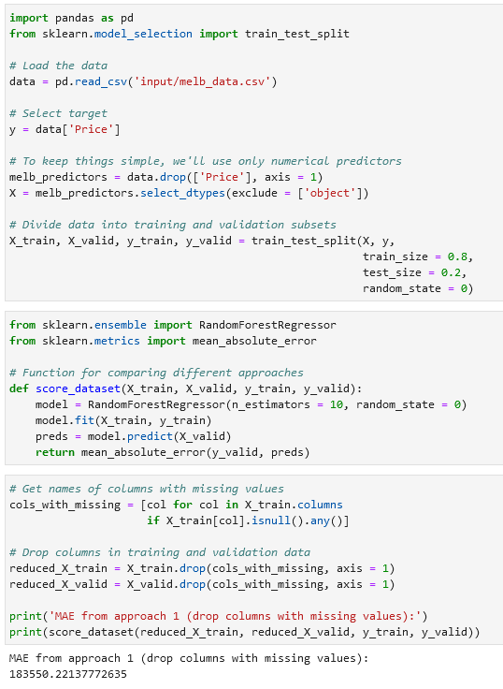

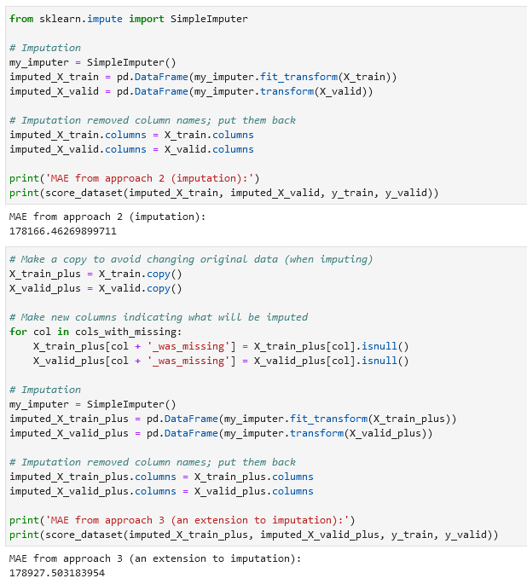

**Check the number of blank values per column:**

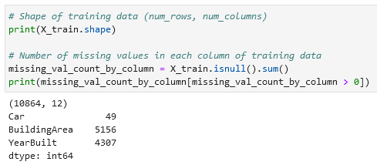

**10.3 Categorical Variables**

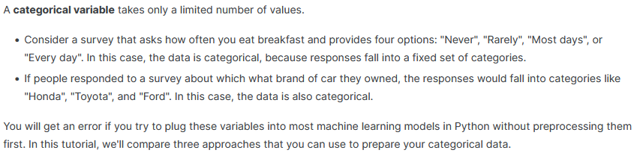

**3 approaches with categorical variables**

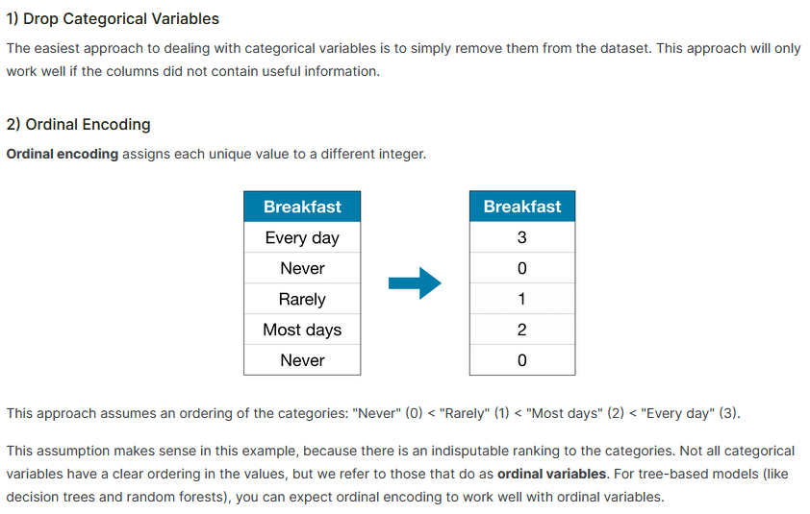

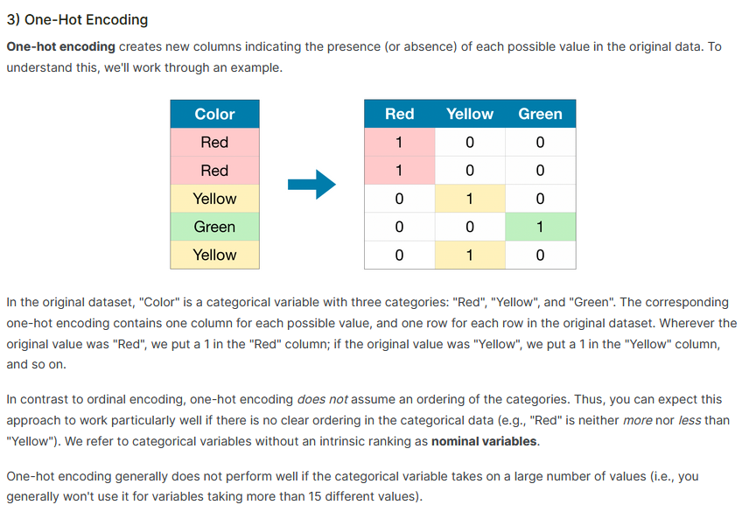

**Cardinality means the number of unique values in a column.**

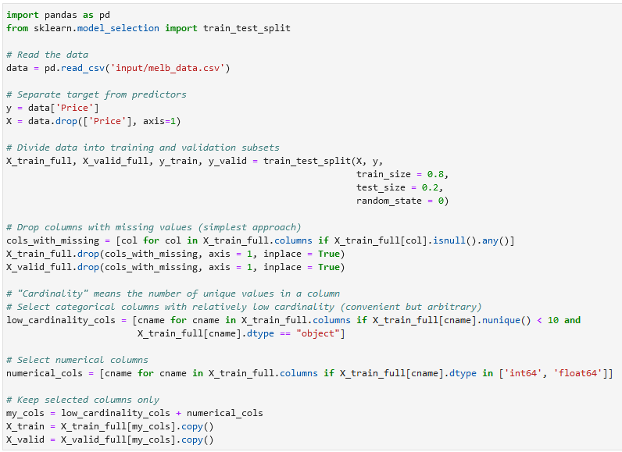

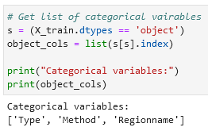

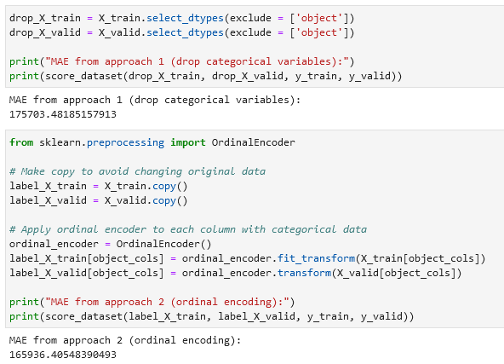

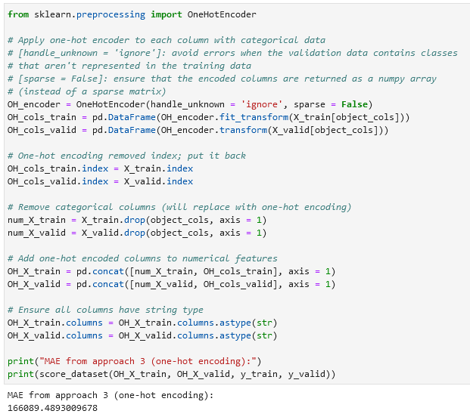

To select columns / drop columns with a specific datatype you can use df.select_dtypes(exclude = ['object']):



Get number of unique entries in each column with categorical data:

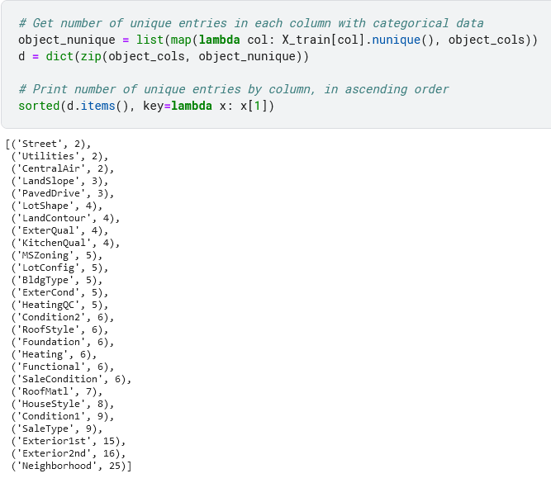

**One-hot encoding:**

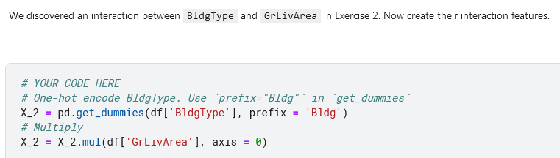

**10.4 Pipelines**

Pipelines are valuable for cleaning up machine learning code and avoiding errors, and are especially useful for workflows with sophisticated data preprocessing.

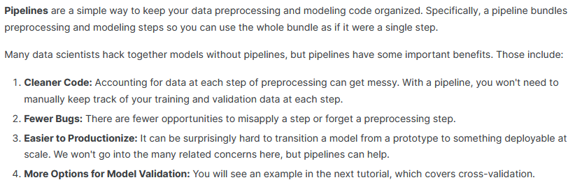

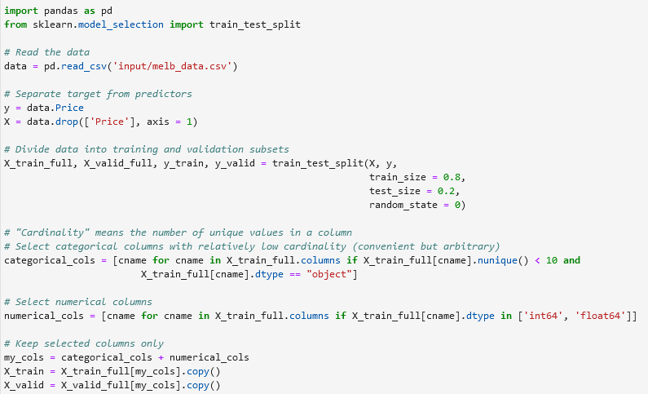

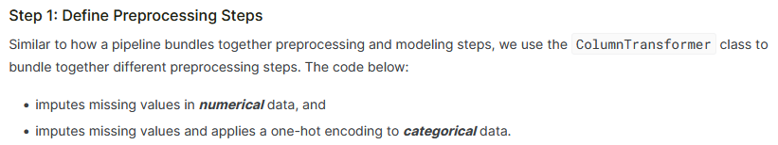

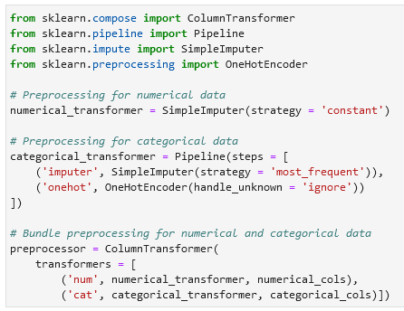

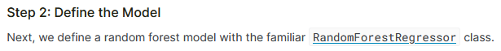

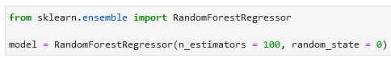

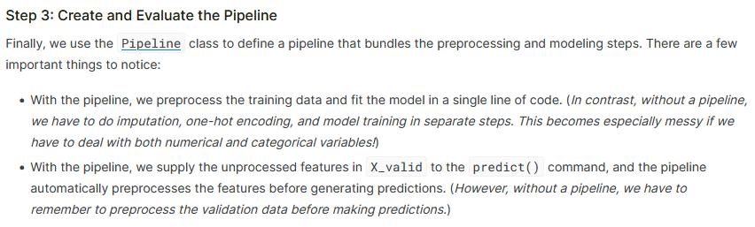

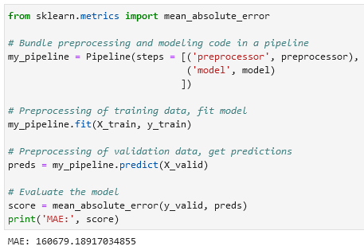

**10.5 Cross-Validation**

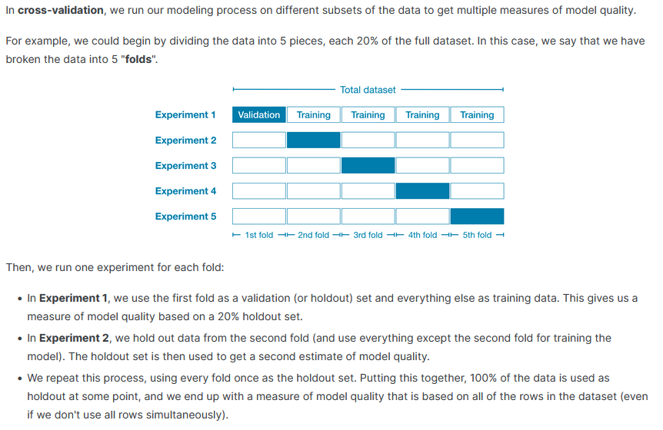

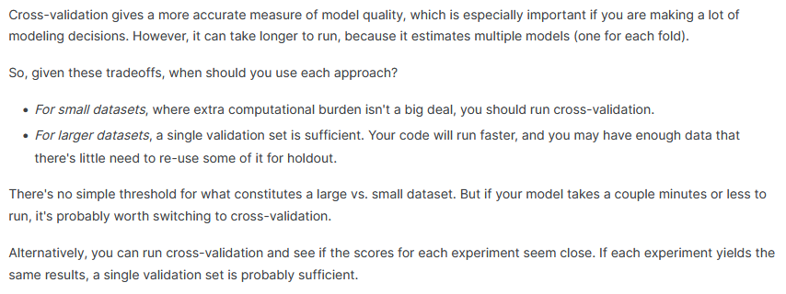

While it's possible to do cross-validation without pipelines, it is quite difficult! Using a pipeline will make the code remarkably straightforward.

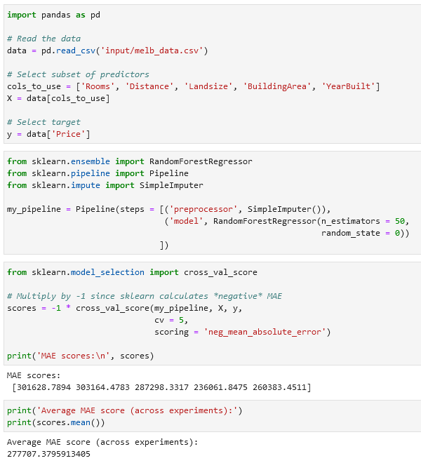

In the code above:

* cv is the number of folds.

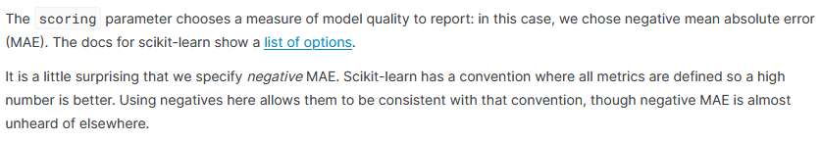

Note on dictionary comprehension: the syntax for dictionary comprehension is {key: value for key, value in iterable}.

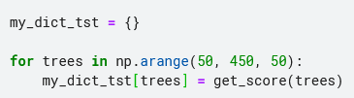 → 

If you'd like to learn more about [**hyperparameter optimization**](https://en.wikipedia.org/wiki/Hyperparameter_optimization), you're encouraged to start with grid search, which is a straightforward method for determining the best combination of parameters for a machine learning model. Thankfully, scikit-learn also contains a built-in function GridSearchCV() that can make your grid search code very efficient!

**Return the smallest number in a dictionary** using min(dict, key = dict.get):

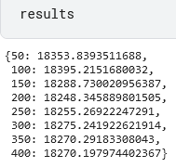

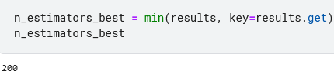

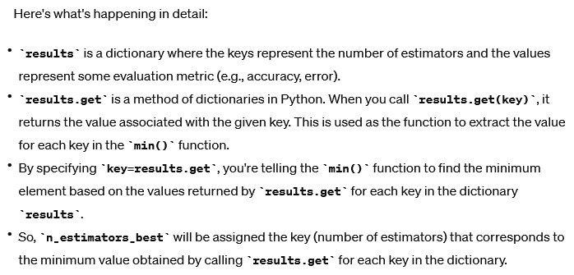

Pipeline with cross-validation:

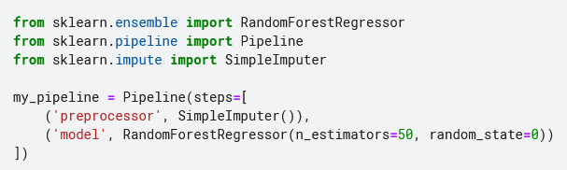

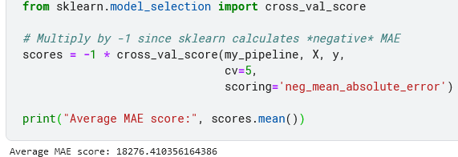

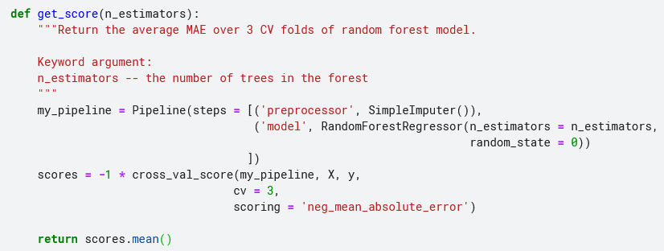



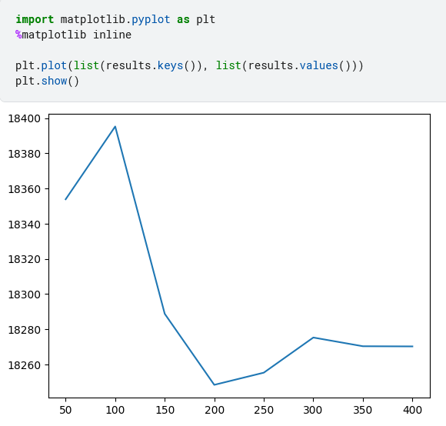

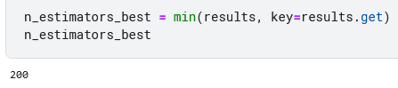

**10.6 XGBoost**

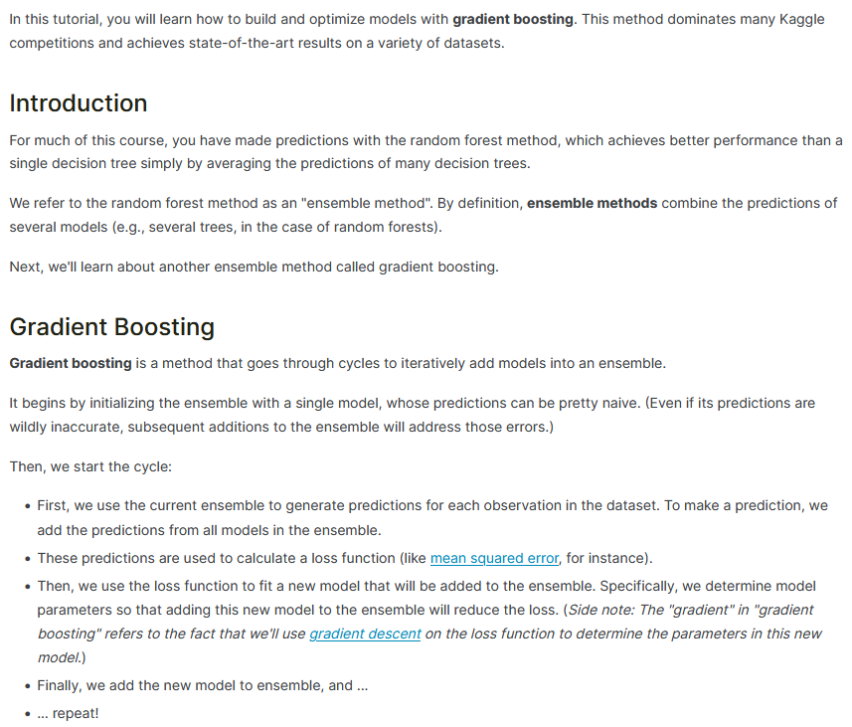

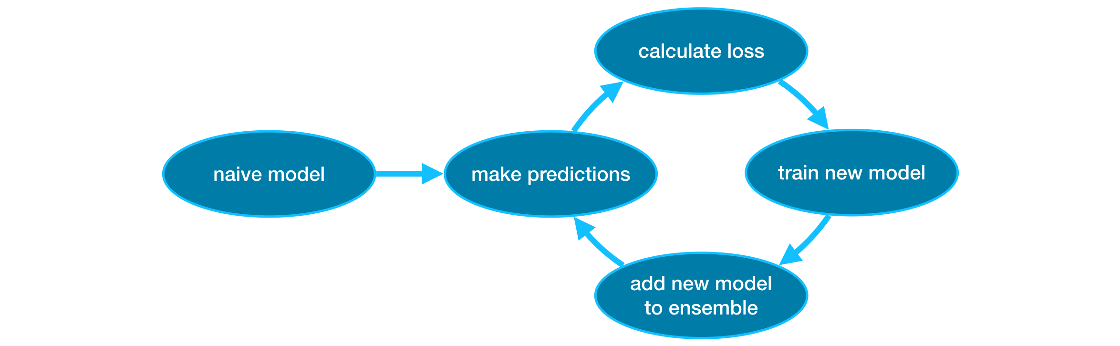

XGBoost example:

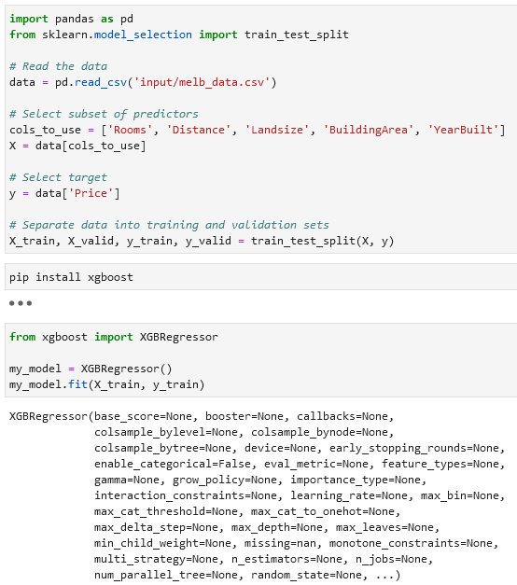

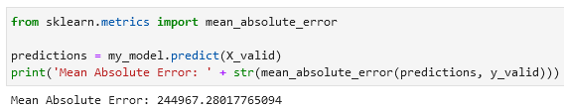

**Parameter tuning**

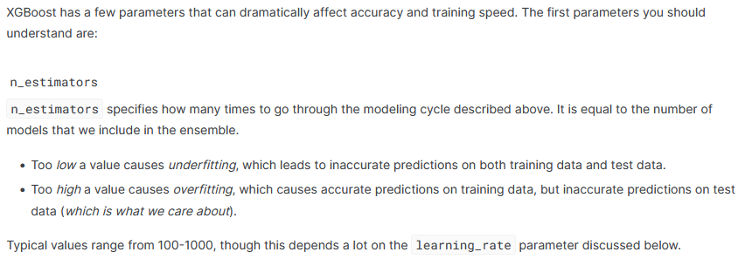

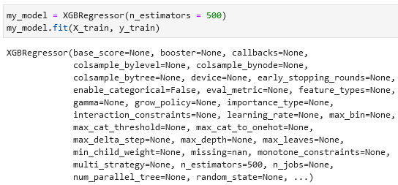

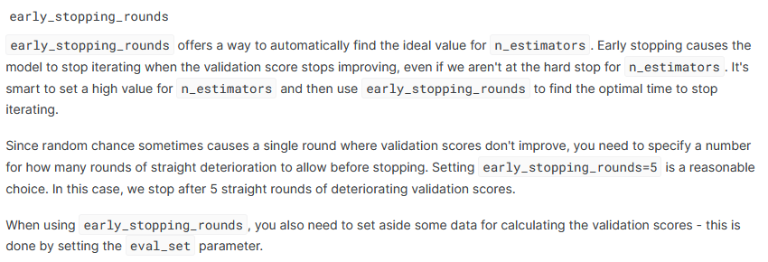

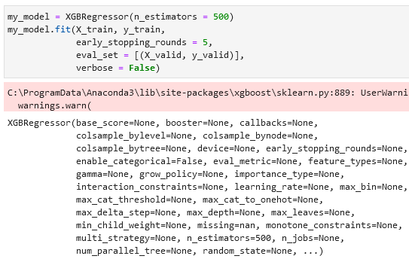

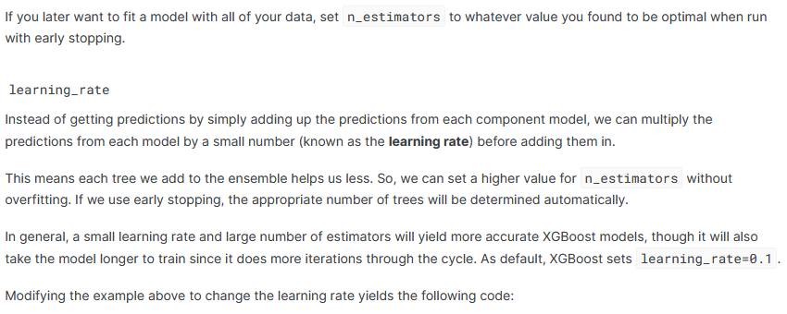

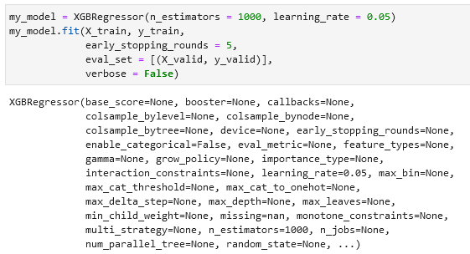

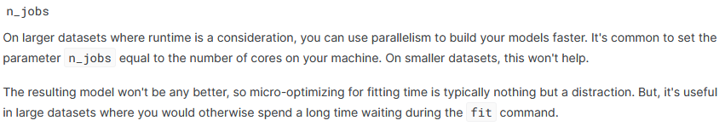

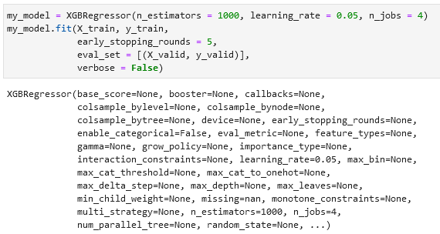

**XGBoost example:**

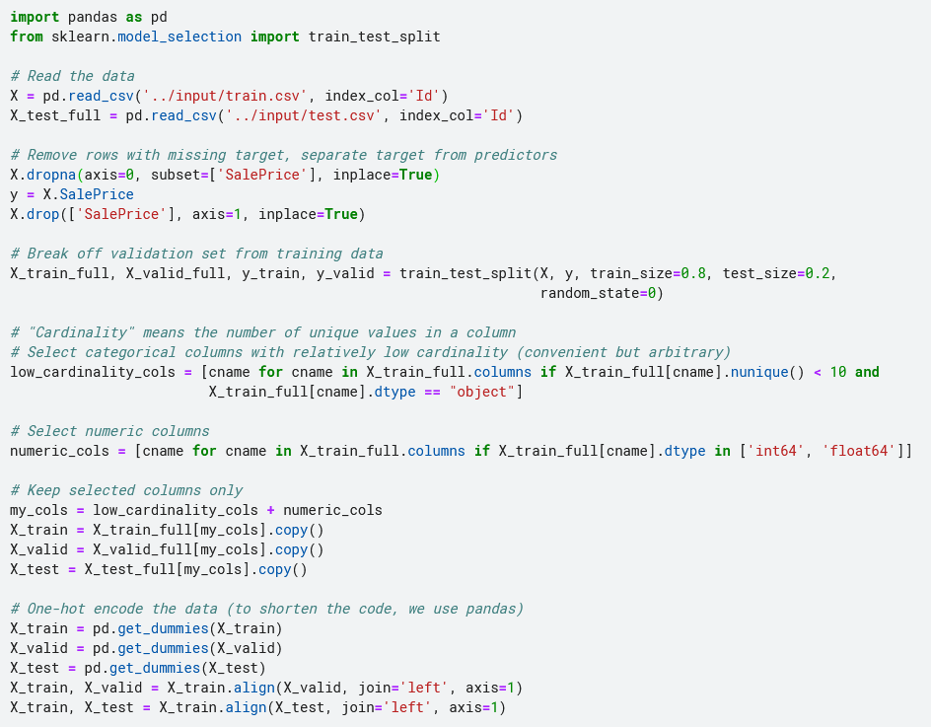

**10.7 Data Leakage**

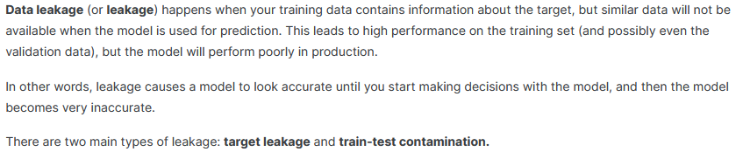

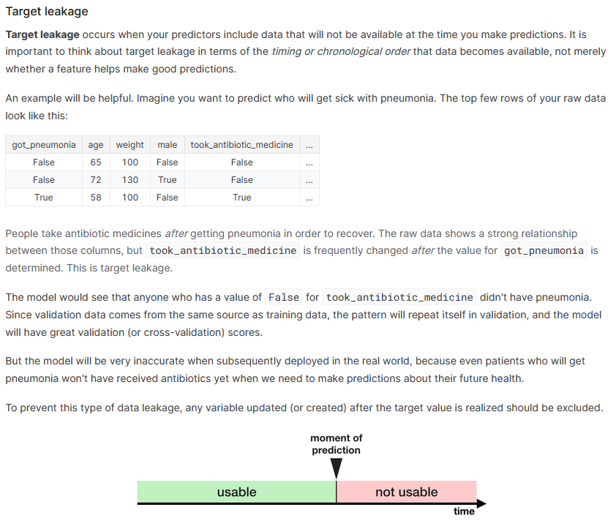

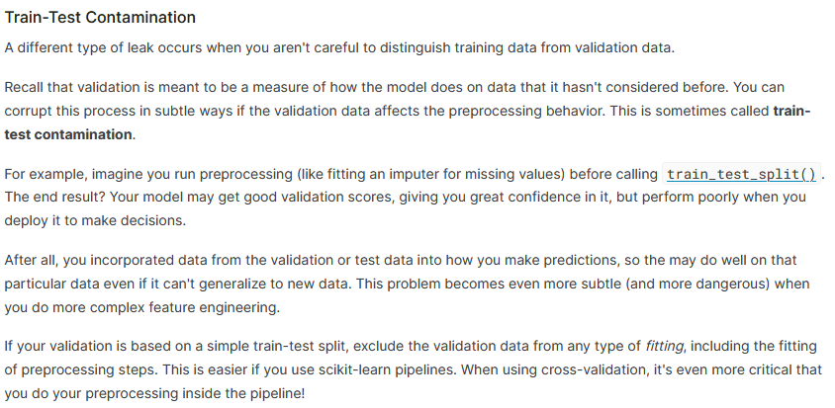

Checking using cross-validation (higher means more suspicious):

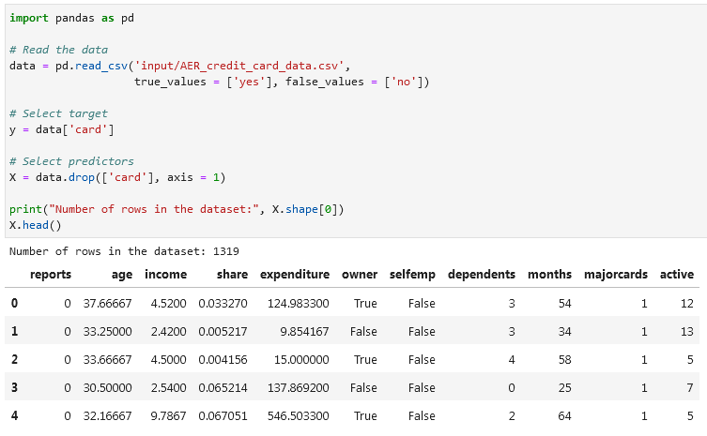

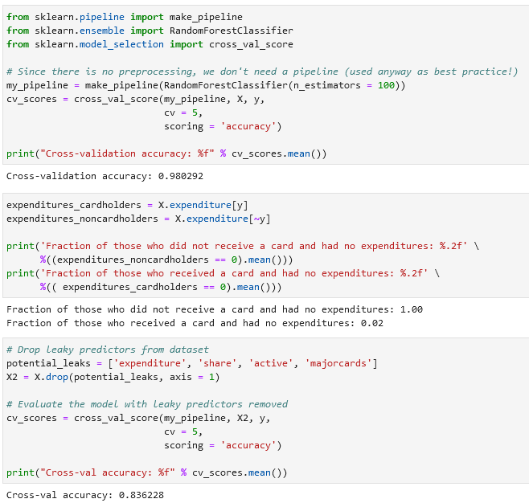

**11. Feature Engineering**

**11.1 What Is Feature Engineering**

You might perform feature engineering to:

* improve a model's predictive performance
* reduce computational or data needs
* improve interpretability of the results

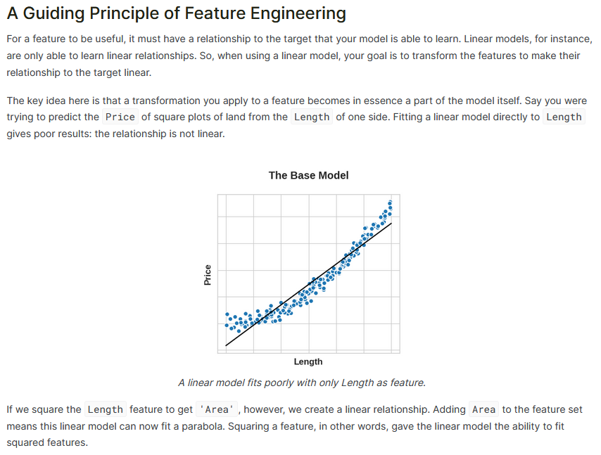

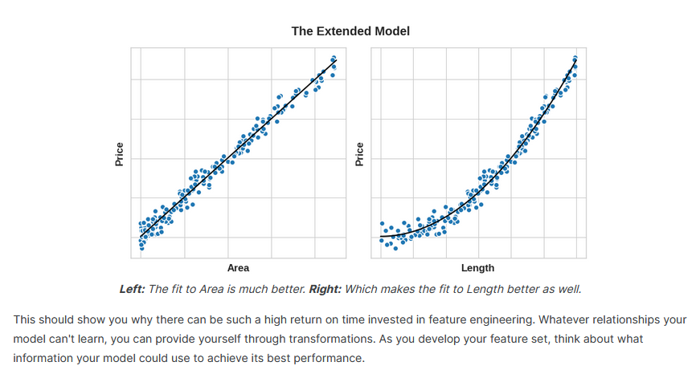

Example with and without features created:

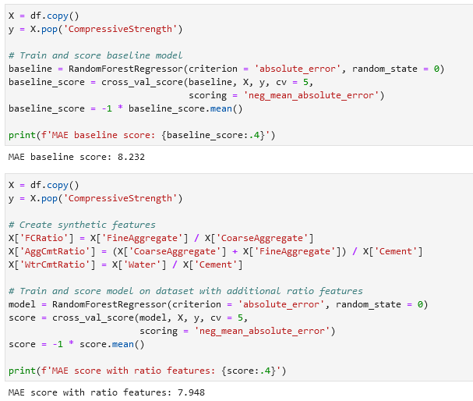

**11.2 Mutual Information**

First encountering a new dataset can sometimes feel overwhelming. You might be presented with hundreds or thousands of features without even a description to go by. Where do you even begin?

A great first step is to construct a ranking with a feature utility metric, a function measuring associations between a feature and the target. Then you can choose a smaller set of the most useful features to develop initially and have more confidence that your time will be well spent.

The metric we'll use is called "mutual information". Mutual information is a lot like correlation in that it measures a relationship between two quantities. The advantage of mutual information is that it can detect any kind of relationship, while correlation only detects linear relationships.

Mutual information is a great general-purpose metric and especially useful at the start of feature development when you might not know what model you'd like to use yet. It is:

* easy to use and interpret,
* computationally efficient,
* theoretically well-founded,
* resistant to overfitting, and,
* able to detect any kind of relationship

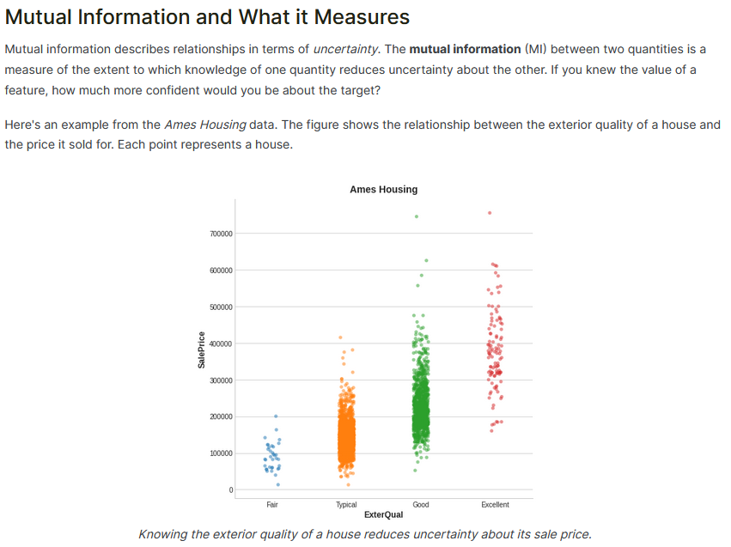

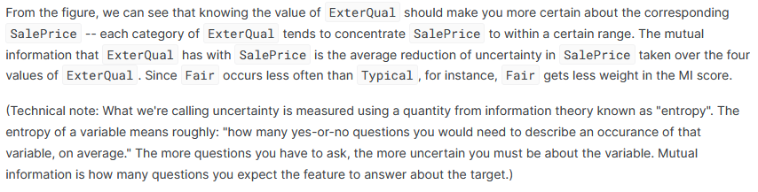

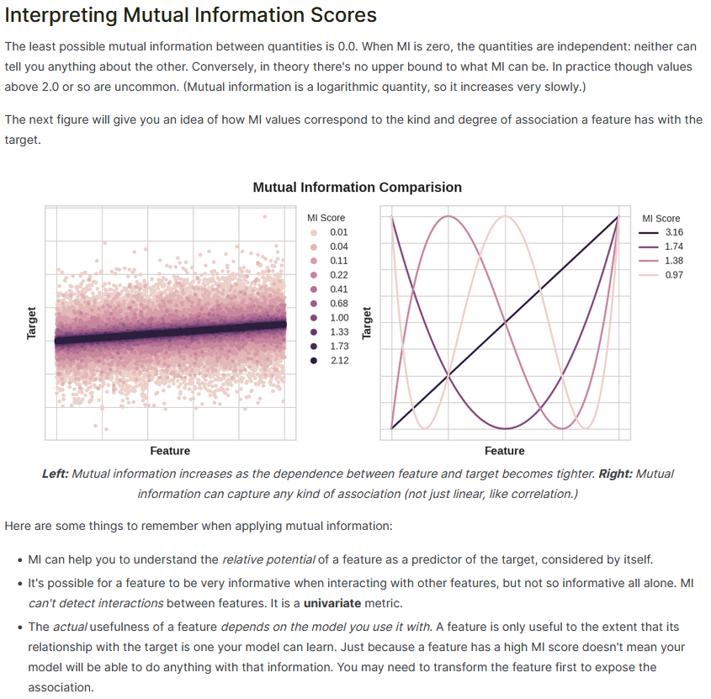

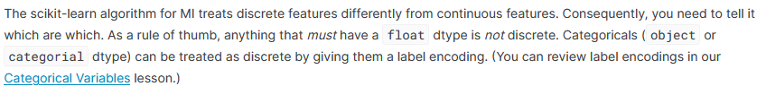

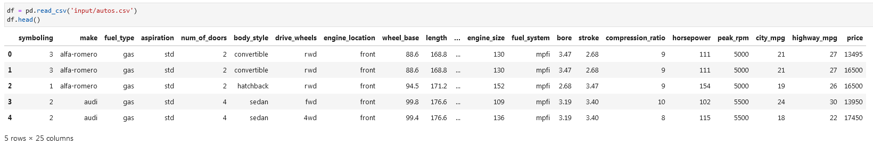

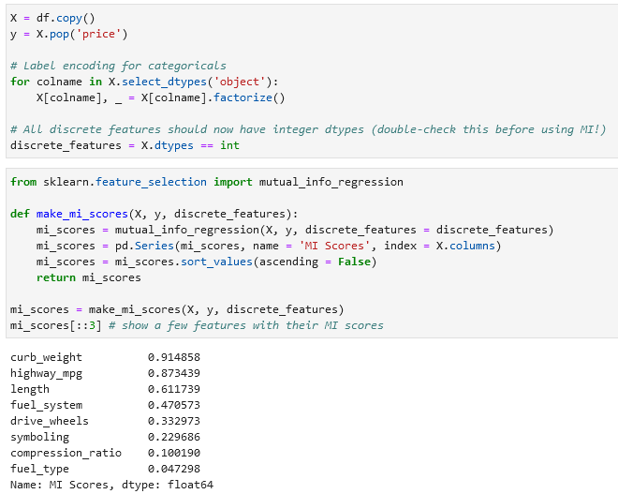

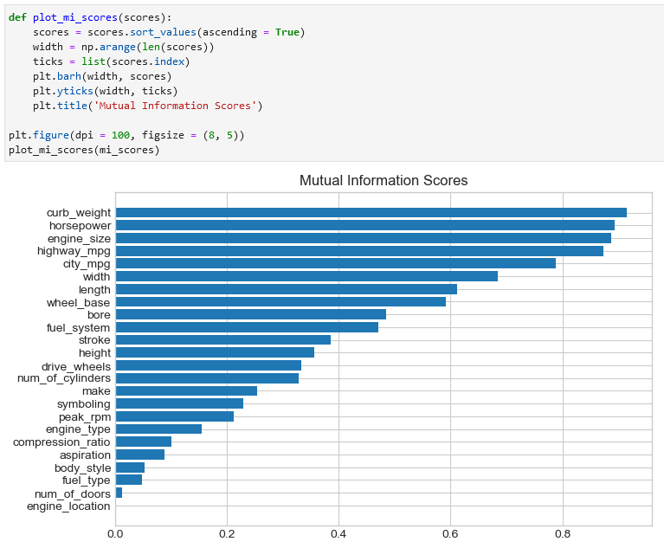

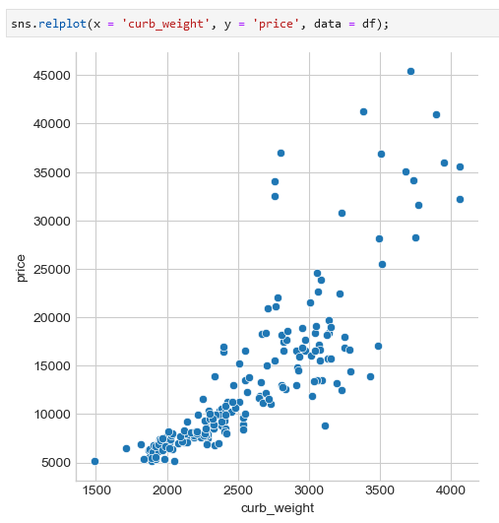

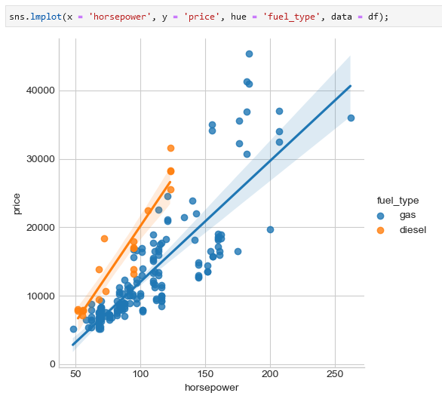

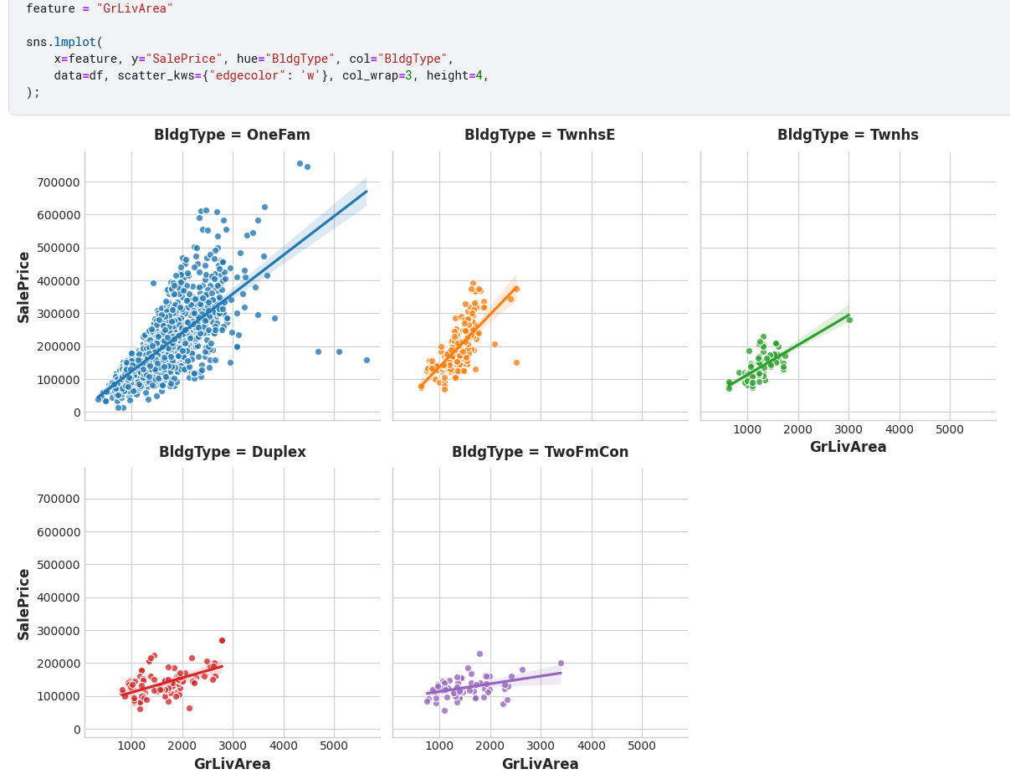

**11.3 Creating Features**

**Tips on Discovering New Features**

* Understand the features. Refer to your dataset's data documentation, if available.
* Research the problem domain to acquire **domain knowledge**. If your problem is predicting house prices, do some research on real-estate for instance. Wikipedia can be a good starting point, but books and [journal articles](https://scholar.google.com/) will often have the best information.
* Study previous work. [Solution write-ups](https://www.kaggle.com/sudalairajkumar/winning-solutions-of-kaggle-competitions) from past Kaggle competitions are a great resource.
* Use data visualization. Visualization can reveal pathologies in the distribution of a feature or complicated relationships that could be simplified. Be sure to visualize your dataset as you work through the feature engineering process.

Applying np.log1p:

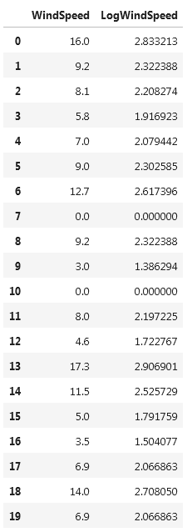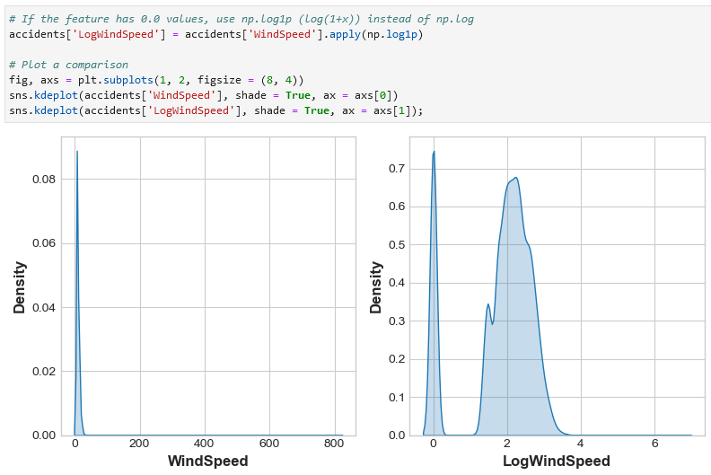

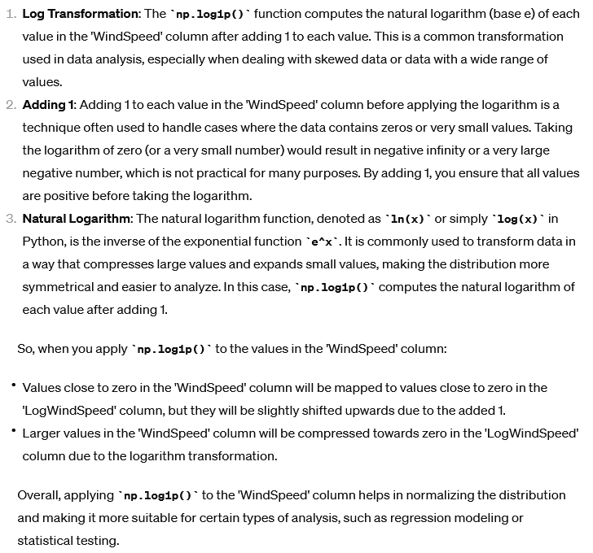

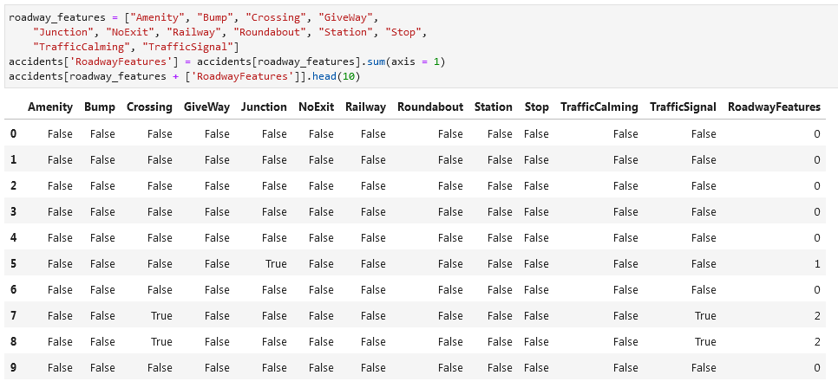

Creating a total row that counts the number of values that are greater than 0 (function .gt(0)):

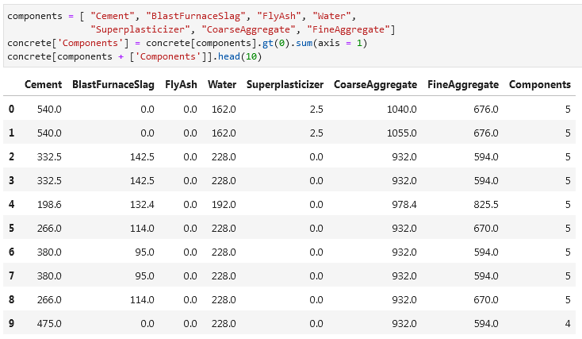

Splitting values into two columns based on space using .str.split():

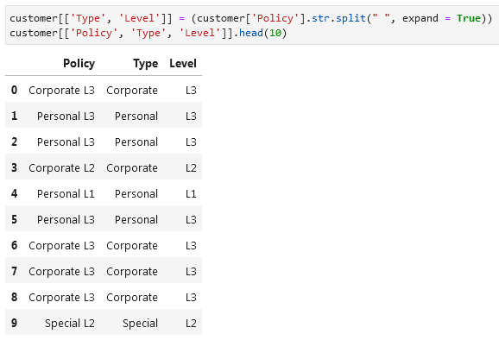

If you want to split only on the first space/underscore and you want to keep only that column:

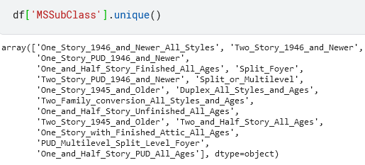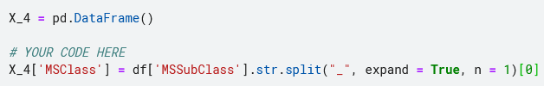

Joining values from two columns into one:

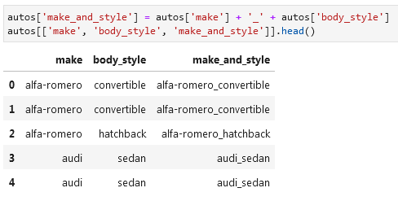

Using groupby you can add columns with information like average X per a column/label:

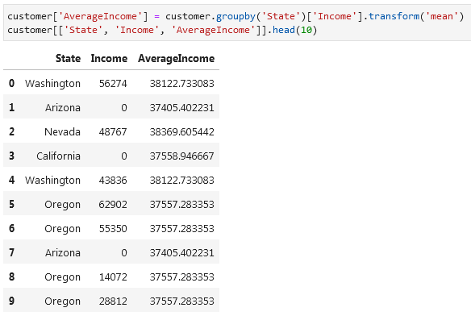

Or the frequency of a category/column/label:

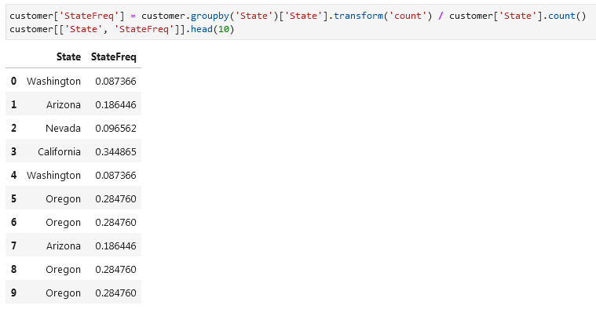

If you're using training and validation splits, to preserve their independence, it's best to create a grouped feature using only the training set and then join it to the validation set. We can use the validation set's merge method after creating a unique set of values with drop_duplicates on the training set:

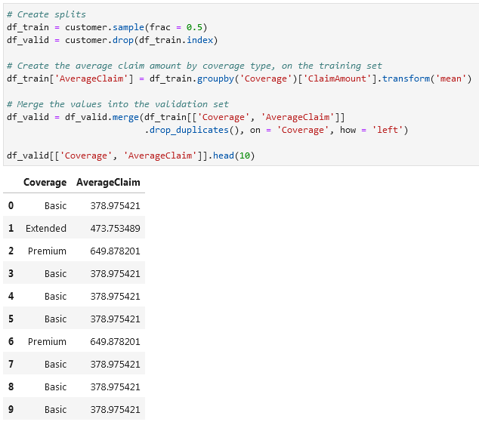

**Tips on Creating Features**  
It's good to keep in mind your model's own strengths and weaknesses when creating features. Here are some guidelines:

* Linear models learn sums and differences naturally, but can't learn anything more complex.
* Ratios seem to be difficult for most models to learn. Ratio combinations often lead to some easy performance gains.
* Linear models and neural nets generally do better with normalized features. Neural nets especially need features scaled to values not too far from 0. Tree-based models (like random forests and XGBoost) can sometimes benefit from normalization, but usually much less so.
* Tree models can learn to approximate almost any combination of features, but when a combination is especially important they can still benefit from having it explicitly created, especially when data is limited.
* Counts are especially helpful for tree models, since these models don't have a natural way of aggregating information across many features at once.

How to select a dataset (e.g. csv), set X-values and y-values. The advantages is that you don’t need to select specific columns for X, but you make a copy of the original DataFrame and then using .pop() you select the column and delete it from the X DataFrame:

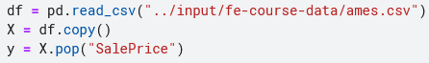

**11.4 Clustering With K-Means**

Unsupervised algorithms don't make use of a target; instead, their purpose is to learn some property of the data, to represent the structure of the features in a certain way. In the context of feature engineering for prediction, you could think of an unsupervised algorithm as a "feature discovery" technique.

**Clustering** simply means the assigning of data points to groups based upon how similar the points are to each other. A clustering algorithm makes "birds of a feather flock together," so to speak.

When used for feature engineering, we could attempt to discover groups of customers representing a market segment, for instance, or geographic areas that share similar weather patterns. Adding a feature of cluster labels can help machine learning models untangle complicated relationships of space or proximity.

**Cluster Labels as a Feature**[**¶**](https://www.kaggle.com/code/ryanholbrook/clustering-with-k-means#Cluster-Labels-as-a-Feature)

Applied to a single real-valued feature, clustering acts like a traditional "binning" or ["discretization"](https://scikit-learn.org/stable/auto_examples/preprocessing/plot_discretization_classification.html) transform. On multiple features, it's like "multi-dimensional binning" (sometimes called *vector quantization*).

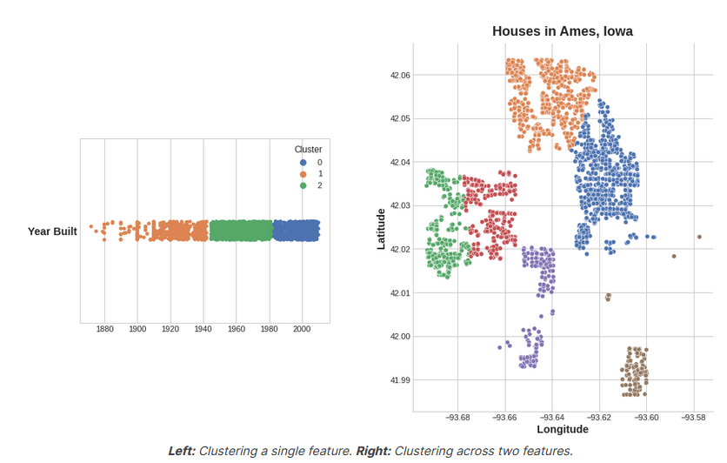

[**Feature discretization¶**](https://scikit-learn.org/stable/auto_examples/preprocessing/plot_discretization_classification.html)

A demonstration of feature discretization on synthetic classification datasets. Feature discretization decomposes each feature into a set of bins, here equally distributed in width. The discrete values are then one-hot encoded, and given to a linear classifier. This preprocessing enables a non-linear behavior even though the classifier is linear.

On this example, the first two rows represent linearly non-separable datasets (moons and concentric circles) while the third is approximately linearly separable. On the two linearly non-separable datasets, feature discretization largely increases the performance of linear classifiers. On the linearly separable dataset, feature discretization decreases the performance of linear classifiers. Two non-linear classifiers are also shown for comparison.

This example should be taken with a grain of salt, as the intuition conveyed does not necessarily carry over to real datasets. Particularly in high-dimensional spaces, data can more easily be separated linearly. Moreover, using feature discretization and one-hot encoding increases the number of features, which easily lead to overfitting when the number of samples is small.

The plots show training points in solid colors and testing points semi-transparent. The lower right shows the classification accuracy on the test set.

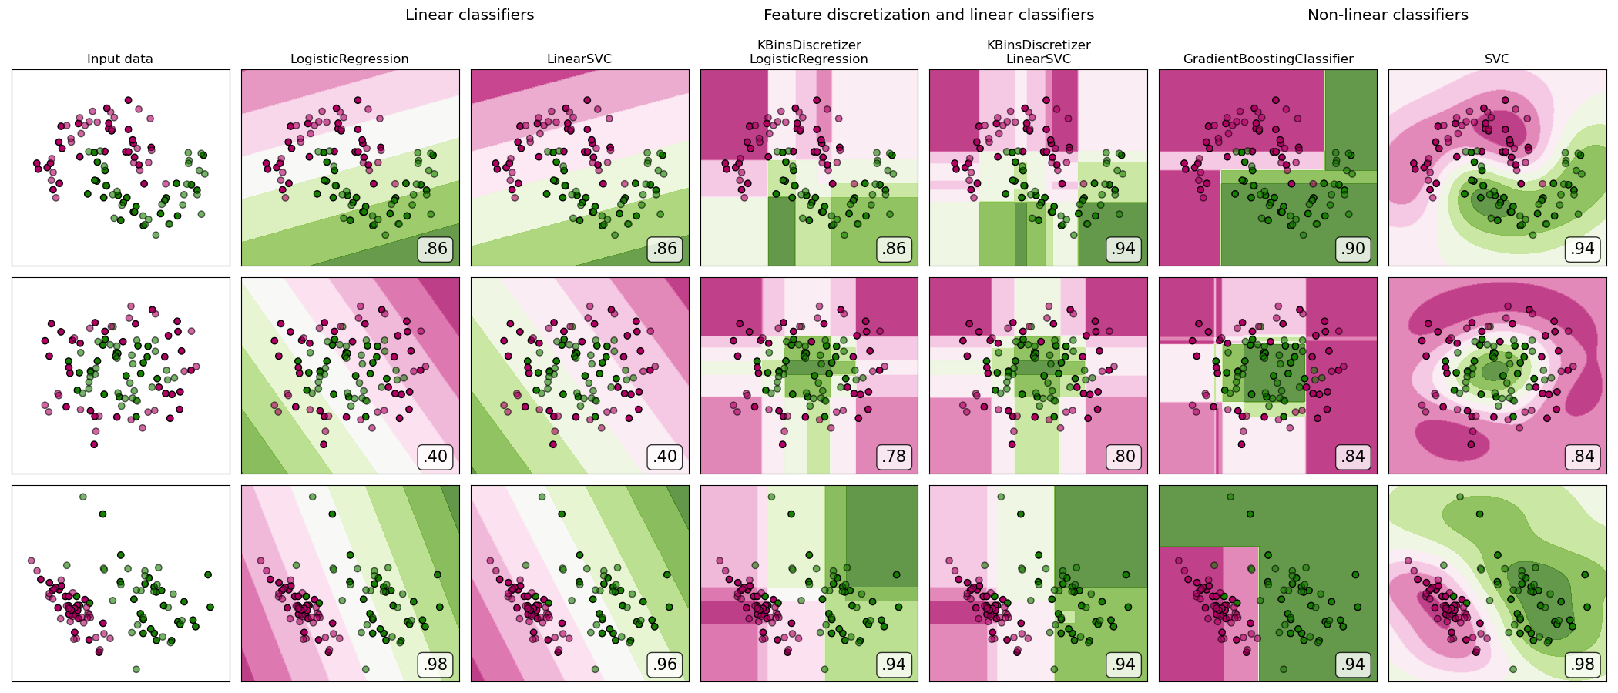

The motivating idea for adding cluster labels is that the clusters will break up complicated relationships across features into simpler chunks. Our model can then just learn the simpler chunks one-by-one instead having to learn the complicated whole all at once. It's a "divide and conquer" strategy.

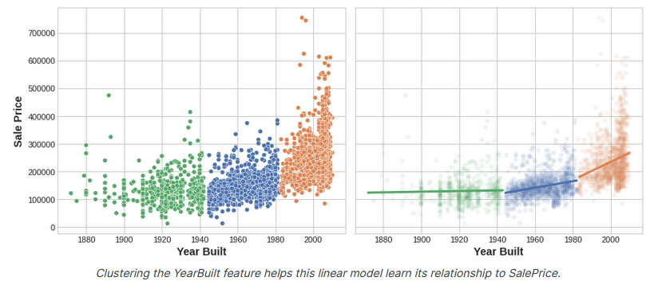

The figure shows how clustering can improve a simple linear model. The curved relationship between the YearBuilt and SalePrice is too complicated for this kind of model -- it *underfits*. On smaller chunks however the relationship is *almost* linear, and that the model can learn easily.

**k-Means Clustering**

There are a great many clustering algorithms. They differ primarily in how they measure "similarity" or "proximity" and in what kinds of features they work with. The algorithm we'll use, k-means, is intuitive and easy to apply in a feature engineering context. Depending on your application another algorithm might be more appropriate.

**K-means clustering** measures similarity using ordinary straight-line distance (Euclidean distance, in other words). It creates clusters by placing a number of points, called **centroids**, inside the feature-space. Each point in the dataset is assigned to the cluster of whichever centroid it's closest to. The "k" in "k-means" is how many centroids (that is, clusters) it creates. You define the k yourself.

You could imagine each centroid capturing points through a sequence of radiating circles. When sets of circles from competing centroids overlap they form a line. The result is what's called a **Voronoi tessallation**. The tessallation shows you to what clusters future data will be assigned; the tessallation is essentially what k-means learns from its training data.

The clustering on the [*Ames*](https://www.kaggle.com/c/house-prices-advanced-regression-techniques/data) dataset above is a k-means clustering. Here is the same figure with the tessallation and centroids shown.

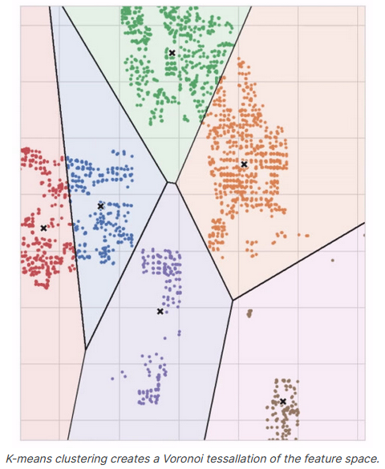

It's a simple two-step process. The algorithm starts by randomly initializing some predefined number (n_clusters) of centroids. It then iterates over these two operations:

1. assign points to the nearest cluster centroid
2. move each centroid to minimize the distance to its points

It iterates over these two steps until the centroids aren't moving anymore, or until some maximum number of iterations has passed (max_iter).

It often happens that the initial random position of the centroids ends in a poor clustering. For this reason the algorithm repeats a number of times (n_init) and returns the clustering that has the least total distance between each point and its centroid, the optimal clustering.

The animation below shows the algorithm in action. It illustrates the dependence of the result on the initial centroids and the importance of iterating until convergence.



The K-means clustering algorithm on Airbnb rentals in NYC.

You may need to increase the max_iter for a large number of clusters or n_init for a complex dataset. Ordinarily though the only parameter you'll need to choose yourself is n_clusters (k, that is). The best partitioning for a set of features depends on the model you're using and what you're trying to predict, so it's best to tune it like any hyperparameter (through cross-validation, say).

**k-means clustering example**

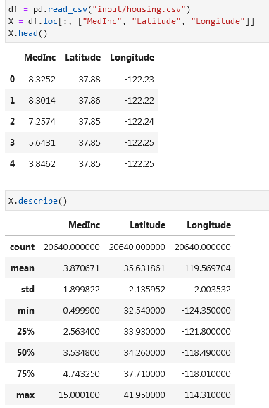

Since k-means clustering is sensitive to scale, it can be a good idea rescale or normalize data with extreme values. Our features are already roughly on the same scale, so we'll leave them as-is.

The k-means algorithm is sensitive to scale. This means we need to be thoughtful about how and whether we rescale our features since we might get very different results depending on our choices. As a rule of thumb, if the features are already directly comparable (like a test result at different times), then you would *not* want to rescale. On the other hand, features that aren't on comparable scales (like height and weight) will usually benefit from rescaling. Sometimes, the choice won't be clear though. In that case, you should try to use common sense, remembering that features with larger values will be weighted more heavily.

Rescaling examples:

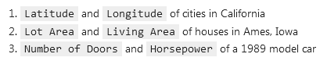

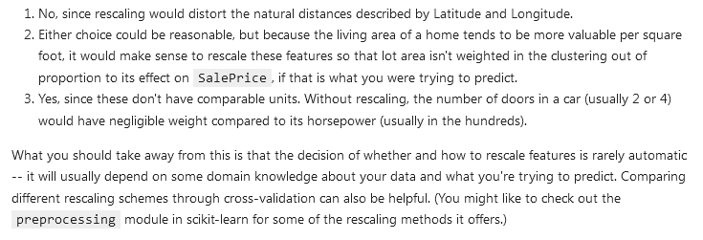

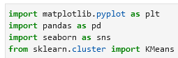

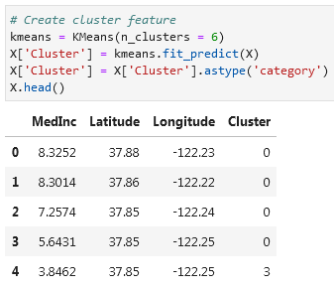

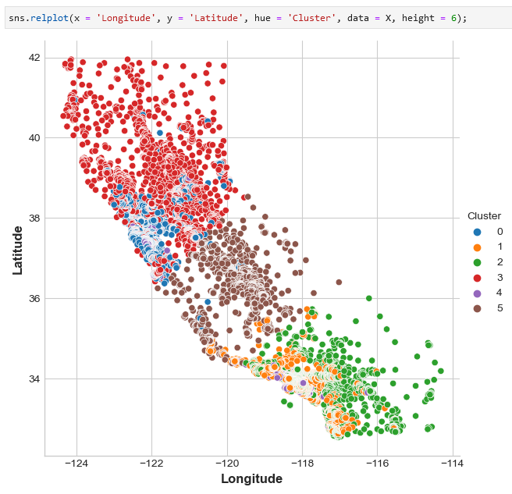

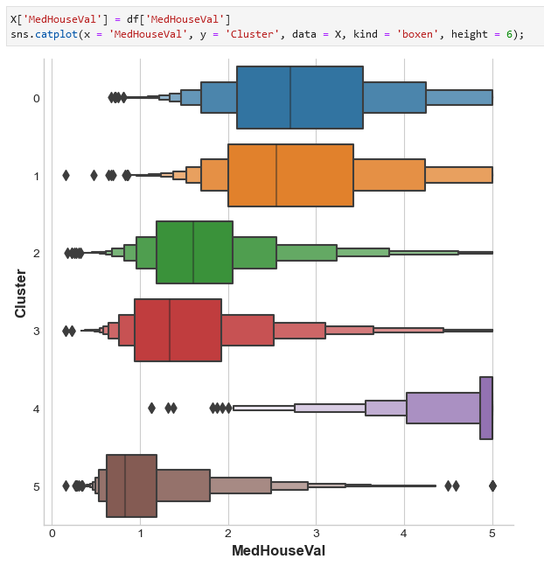

**Another k-means clustering example:**

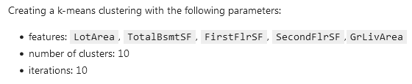

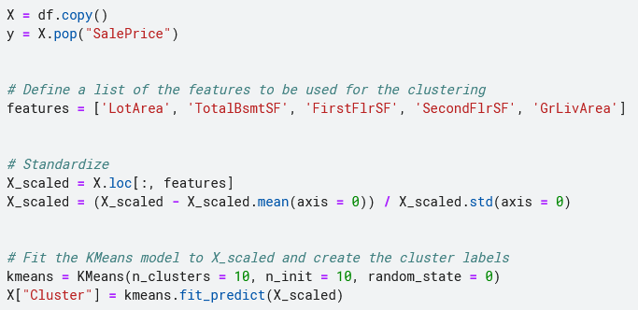

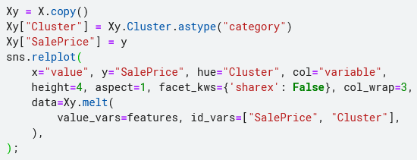

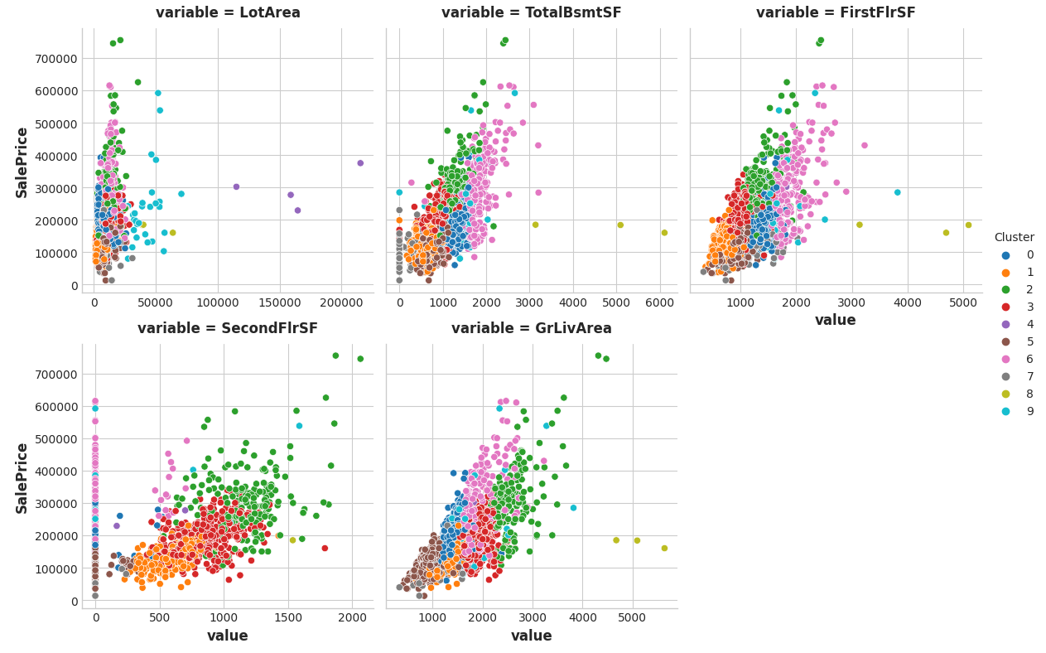

The k-means algorithm offers an alternative way of creating features. Instead of labelling each feature with the nearest cluster centroid, it can measure the distance from a point to all the centroids and return those distances as features.

Now add the cluster-distance features to your dataset. You can get these distance features by using the fit_transform method of kmeans instead of fit_predict.

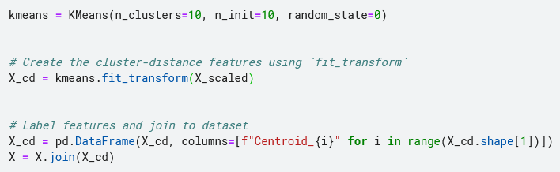

**11.5 Principal Component Analysis**